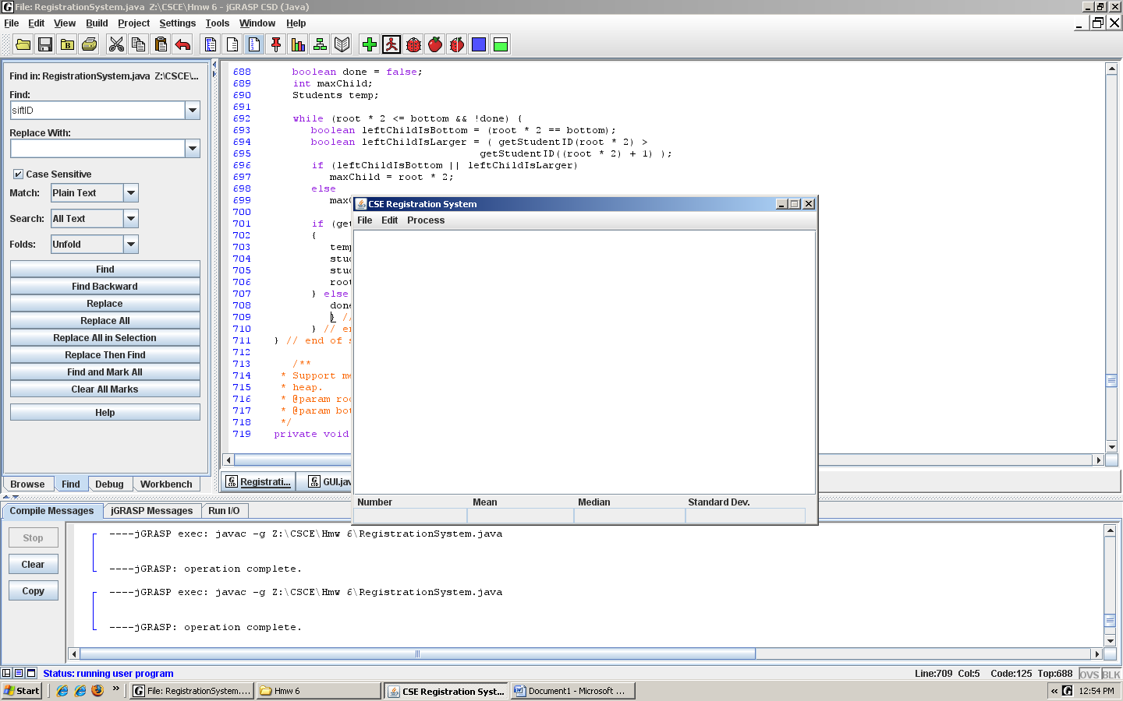

The main GUI.

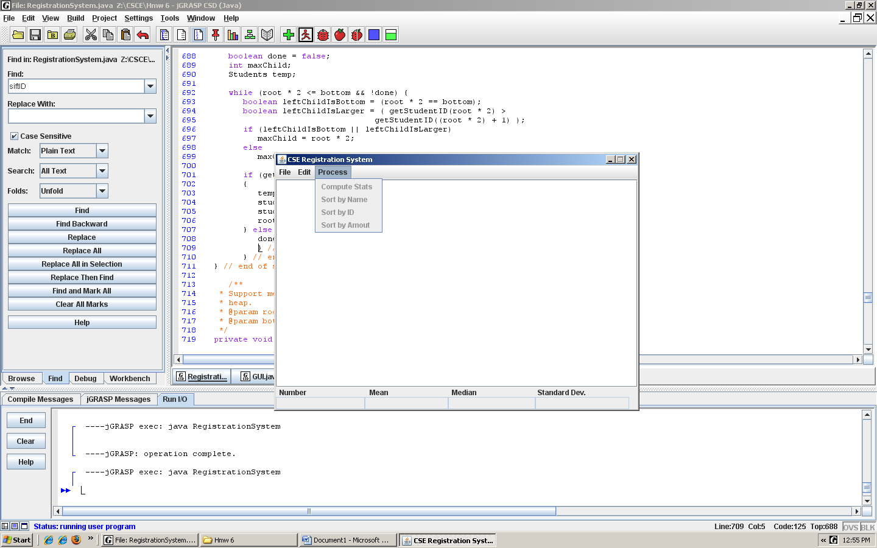

Every Process Gray out prior to load a file.

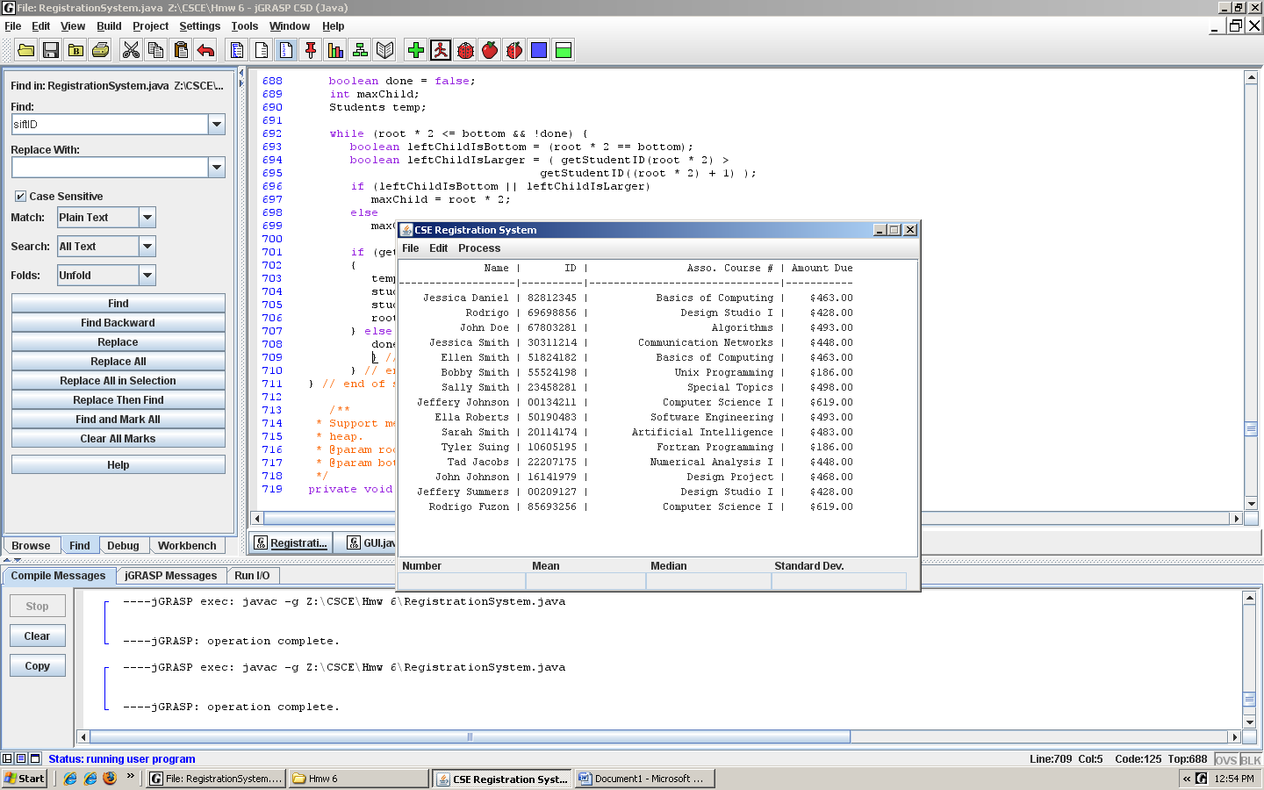

Students Load File.

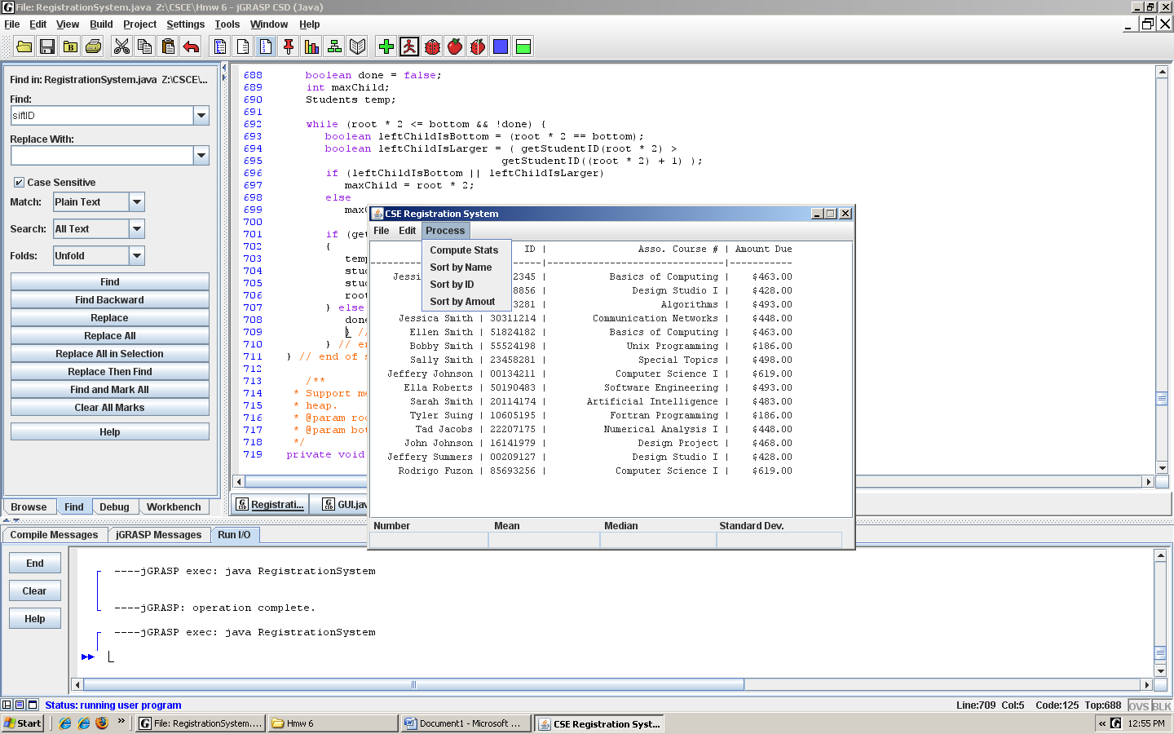

Information Available to Click.

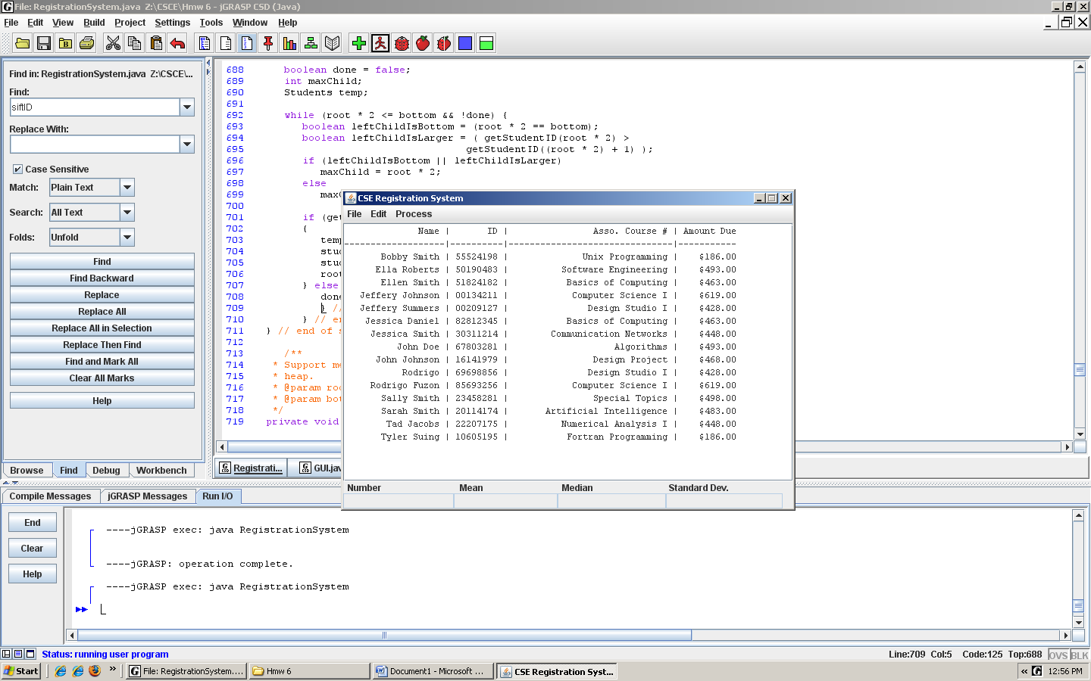Sort by Name

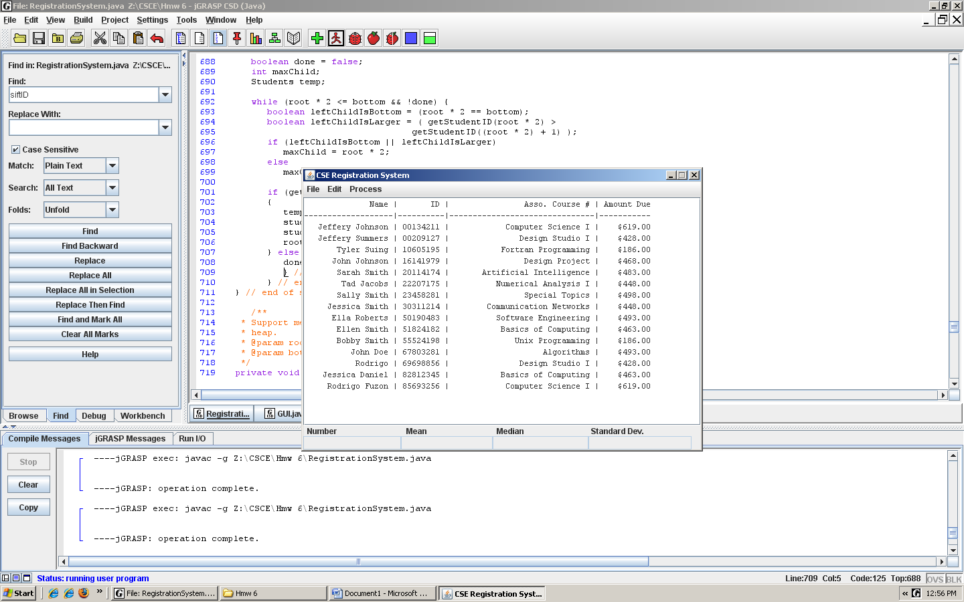

Sort by ID.

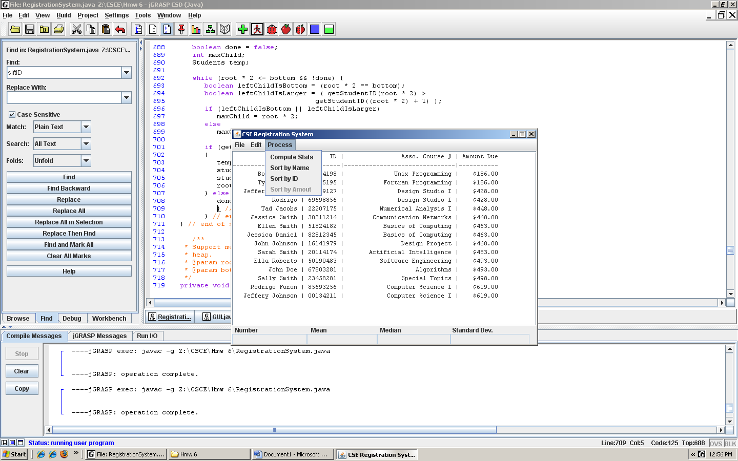

Sort by amount. Every time clicked on a Process, the clicked action gray it out.

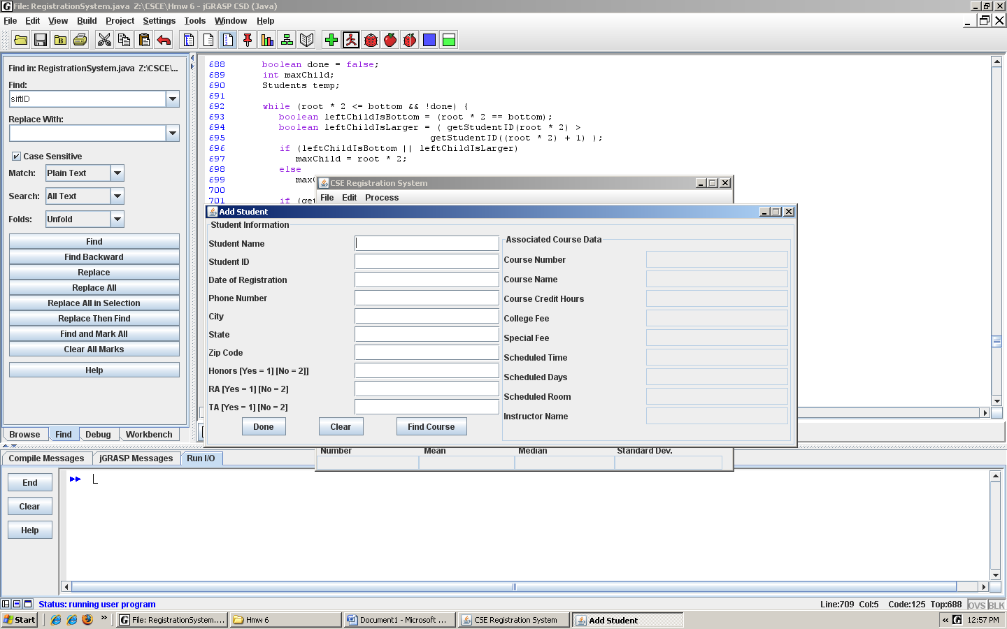

Adding Student, Honors info, Ra and TA. Typing 1 selects the info for Yes and 2 for No.